**DAILY ONLINE ACTIVITIES SUMMARY**

|  |  |  |  |  |  |  |  |  |
| --- | --- | --- | --- | --- | --- | --- | --- | --- |
| **Date:** | **10/06/2020** | | | | | **Name:** | **ASHISH GRACION MENEZES** | |
| **Sem & Sec** | **4&A** | | | | | **USN:** | **4AL18CS012** | |
| **Online Test Summary** | | | | | | | | |
| **Subject** | | **OBJECT ORIENTED CONCEPTS** | | | | | | |
| **Max. Marks** | | **30** | | **Score** | | | **18** | |
| **Certification Course Summary** | | | | | | | | |
| **Course** | **INTRODUCTION TO R** | | | | | | | |
| **Certificate Provider** | | | **Great learning** | | **Duration** | | | **3 hours** |
| **Coding Challenges** | | | | | | | | |
| **Problem Statement1:Write a C program to print the sum of boundary elements of a matrix** | | | | | | | | |
| **Status:Executed** | | | | | | | | |
| **Uploaded the report in Github** | | | | | **YES** | | | |
| **If yes Repository name** | | | | | **https://github.com/ash7745/lockdown-coding** | | | |
| **Uploaded the report in slack** | | | | | **YES** | | | |

Online Test Details1:18CS43(OOC) I.A 4 was conducted on 10/06/2020.There were 15 questions (MCQ programming) with each question carrying 2 marks .The time allotted for the test was 30 min .The portion for I.A. 4 was from module 3 and 4

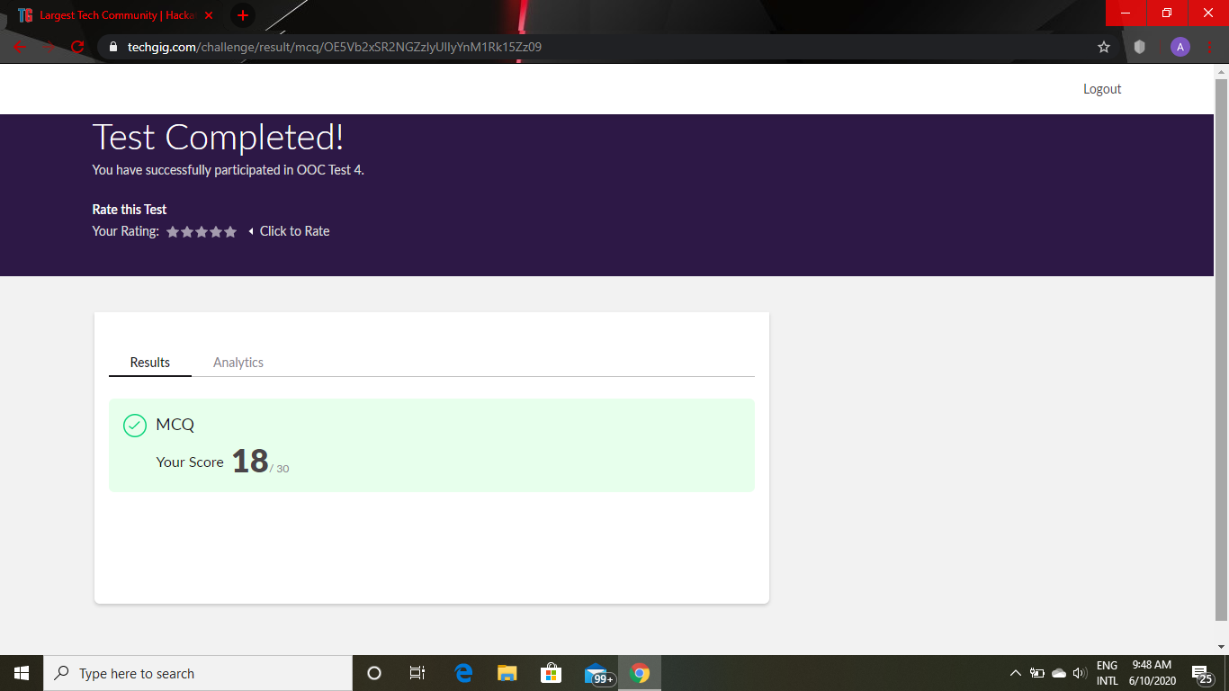

Certification Course Details: INTRODUCTION TO R

I had started a new course today.The duration of the course is 3 hours and I have completed the course .The course consisted of 2 assessments and I have successfully completed the 2 assessments with more than 90% of marks and I have obtained the e-certificate.

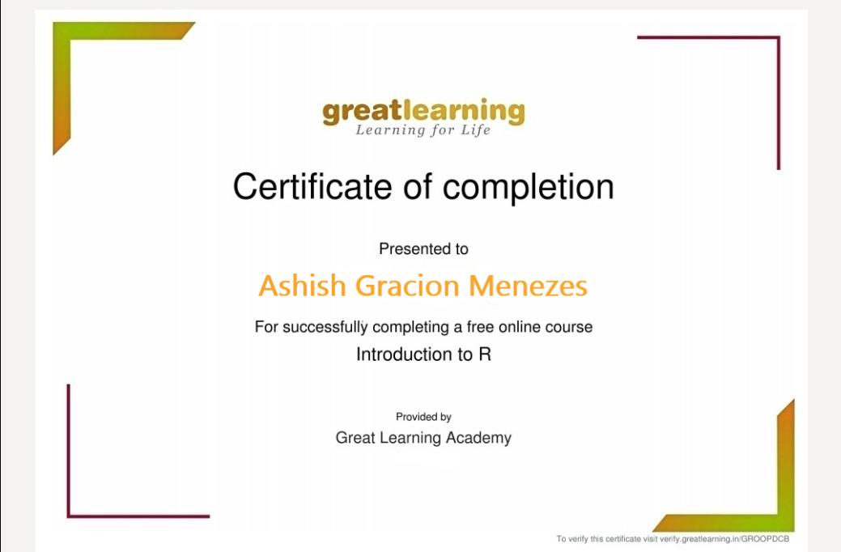

Certification details: BRAIN COMPUTER INTERFACE

I had attended a 3 hours webinar on BRAIN COMPUTER INTERFACE on june 05 which was hosted by NITK-STEP in association with PANTECH.

Snapshot:

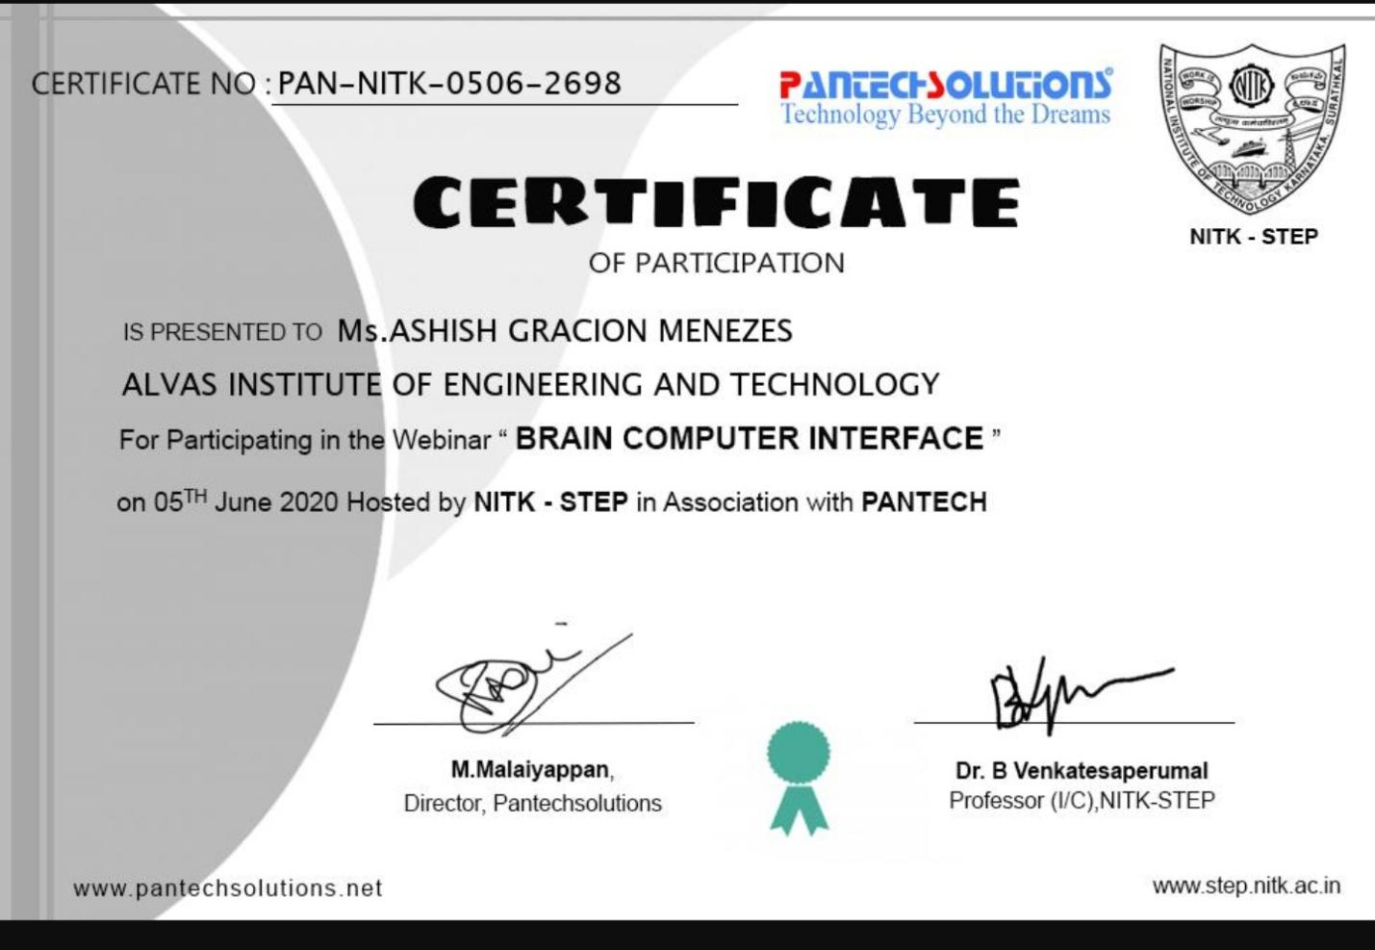

CODING DETAILS: Write a C program to print the sum of boundary elements of a matrix

